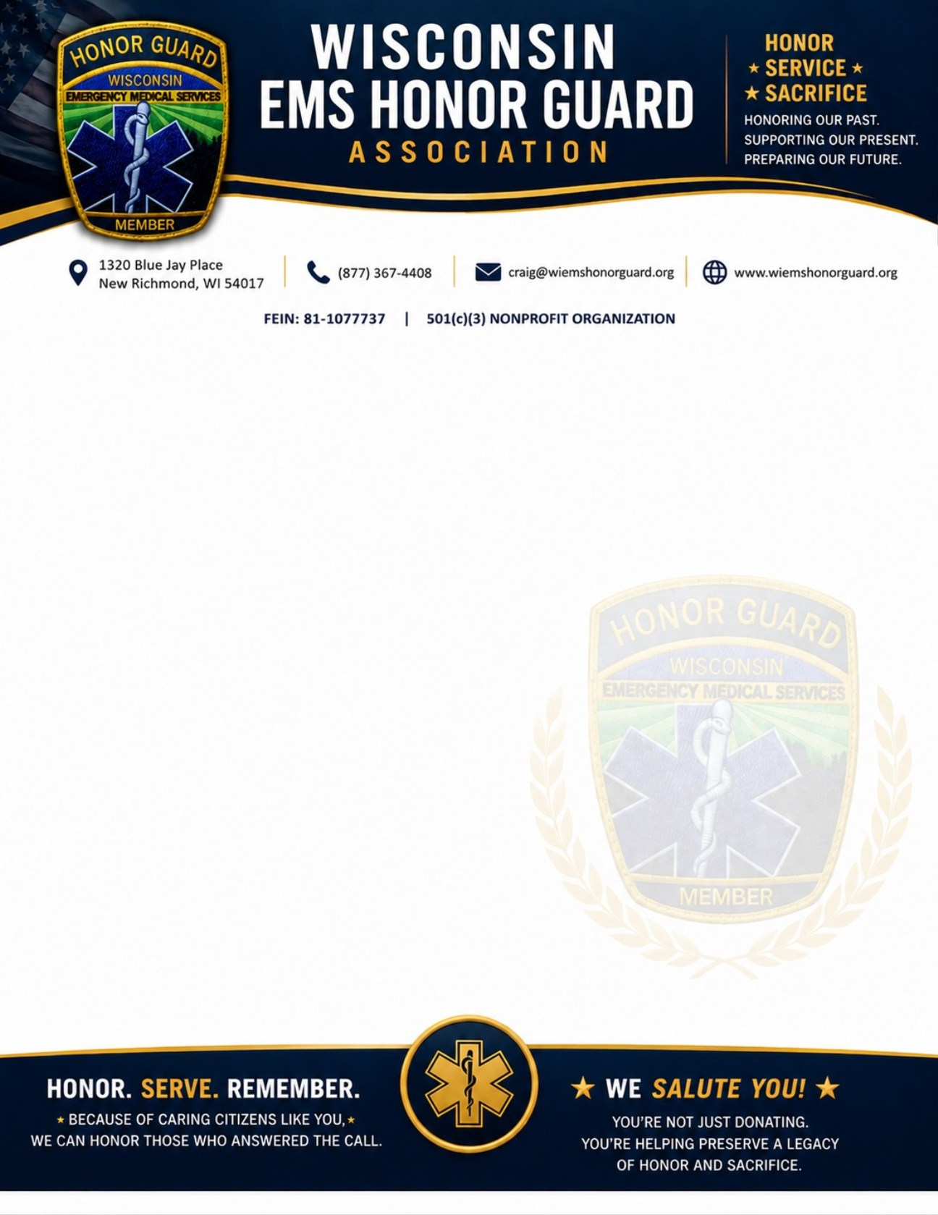
HONORING THOSE WHO SERVED EMS
Support the Wisconsin EMS Honor Guard Association
Join us in honoring the dedicated EMS professionals who serve our communities in Wisconsin. Our members provide dignified funeral honors and ceremonial support, ensuring these heroes and their families receive the respect they deserve, and Color Guard services at a variety of events. Each Ceremonial Class A Uniform Costs $750

Your tax-deductible donation will help cover the cost of a ceremonial uniform for the member speaking to you, a local EMT who serves your community by caring for patients, and services for the statewide honor guard at their own cost. Consider sponsoring a volunteer member’s uniform—your support makes a real difference.

WHO WE ARE
The Wisconsin EMS Honor Guard Association is a 501(c)3 nonprofit, composed of volunteer EMS professionals dedicated to honoring their peers with dignity and compassion. We provide ceremonial honors, support during Line of Duty Deaths, memorial services, and color guard presentations in WI.

WHAT WE PROVIDE
Funeral Honors and Ceremonial Support, Color Guard Presentations, Memorial Services, Family Support Assistance, Support to LOCAL AMBULANCE SERVICES, First Responder crisis network, and Statewide Line of Duty Death Response

WHY YOUR SUPPORT MATTERS
As all members are volunteers, your contributions are vital to our mission. Thank you for considering a donation!

DONATION RECEIPT
Received $______________________________________________ Date: _______________
From __________________________________________________
HG Member Name: _______________________________________
For Honor Guard Uniform Support / Expenses
Wisconsin EMS Honor Guard Association, Inc.501(c)(3) Nonprofit Organization, FEIN: 81-1077737
Thank You for Your Tax-Deductible Contribution.

